

Cadmus Inclusive

Thinking differently for a brighter tomorrow...

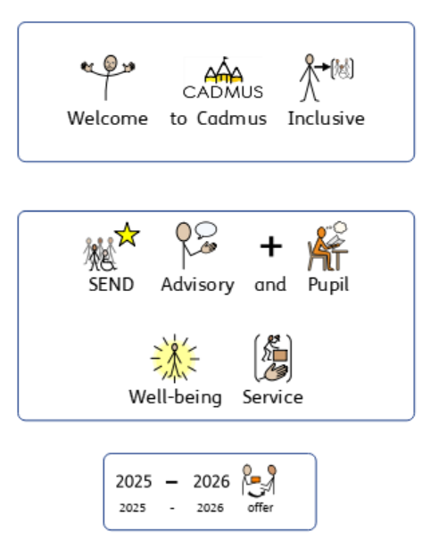

Cadmus Inclusive: SEND Advisory and Pupil Well-Being Service
Service Level Agreement for School Visits

Inclusion Consultant Team

We can offer individually tailored visits to your school. Virtual support is also available. Each visit lasts up to three hours and could feature:
Pupil Support:
- Assessment of pupil needs which can include observation, pupil voice, direct work, standardised assessment, a comprehensive case history, discussions with parents/carers and staff.
- Comprehensive written feedback.
- Support to plan, differentiate and deliver a personalised curriculum.
- Progress reviews.
- Adaptive classroom teaching advice.
- Identification of dyslexia if appropriate.

SENCo Leadership Support to:
- Review and develop policies and procedures including your SEND Information Report.
- Effectively and efficiently implement local and national directives, including the SEND Code of Practice.
- Gather evidence for and produce high quality requests for Education and Health Care needs assessments.
- Evidence pupil progress.
- Plan for innovation.

Curriculum Development:
- Teaching and learning advice – matching adaptive approaches and scaffolding to pupil needs to maximise progress.
- Facilitating greater engagement and independence.

INSET Delivery:
- Bespoke INSET sessions designed in partnership with you delivered in person or virtually.

OFSTED:
- Support with preparation for OFSTED.
- Post OFSTED support to action plan and develop.

SEND Review:
- An in depth review of all aspects of SEND policy, practice and provision with the development of a supportive action plan.

SEND Advisory and Pupil Well-Being Service (Academic Year 2025 – 2026)
Purchase Order Number
School/Setting Name and Address
SENCo/Inclusion Leader contact details (name, telephone and email)
Head Teacher contact details (name, telephone and email)

Who should we invoice (name, telephone and email)?
Purchase Order for a Service Level Agreement - School Visits
Inclusion Consultant Team

Costs
One-year service level agreement from September 2025 to July 2026: £310 per session dropping to £280 per session if 10 or more visits are purchased for the academic year.

Number of Visits Required for September 2025 to July 2026
Total Cost of Purchase

Once we receive your purchase order a member of the team will contact you to book an initial visit and share our service level agreement.

Once a school visit/training session has been booked with one of our consultants we require a minimum of 7 working days’ notice to make a cancellation. This is unless there is an OFSTED inspection. In this case we will attempt to find a mutually convenient replacement date. Should a session be unfortunately cancelled by one of our consultants a replacement session will be offered.

Please return your purchase order to Beccie Hawes, Chief Executive Officer
bhawes @cadmussupportservices.co.uk

Meet our Inclusion Consultant Team

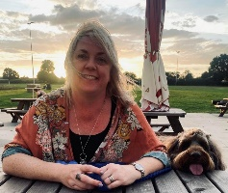  Beccie Hawes, Chief Executive Officer |  | 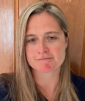  Emma Yates, Deputy Head of Service
Inclusion Consultants
  Gemma Ivens |   Ruth Lue-Quee |  | 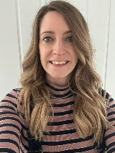  Ali Rolph
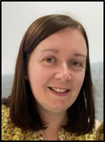  Laura Timmins | 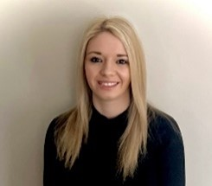  Jordan Jacks |  |   Steph Mayou
SEND Strategic Support Consultant

Simon Muller

