

Thinking differently for a brighter tomorrow...

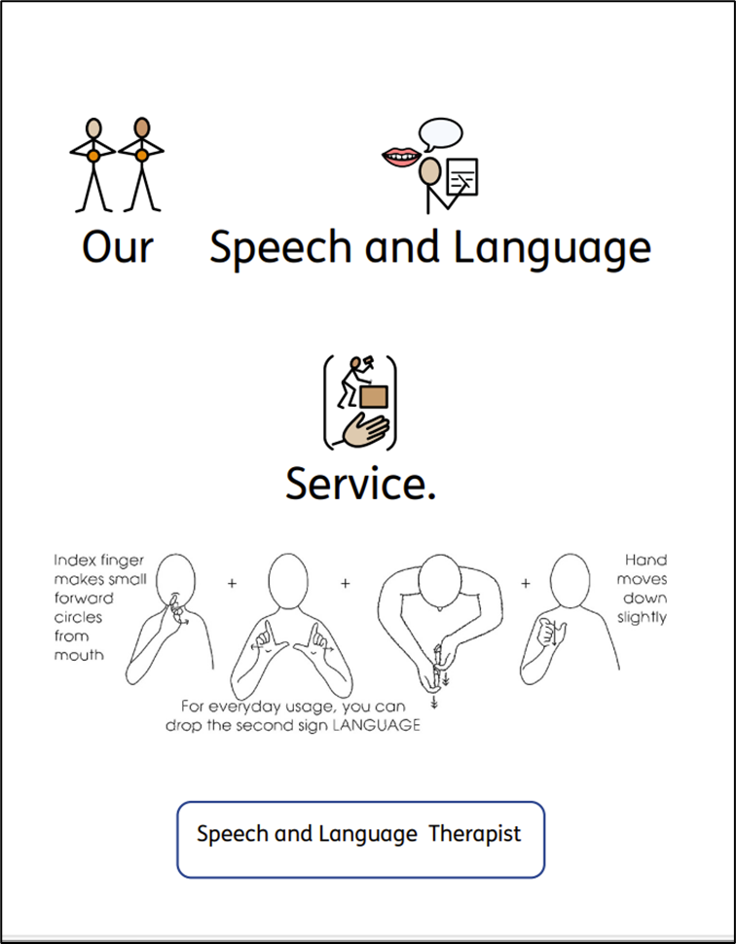

The ability to communicate in a meaningful way is as essential life skill. We recognise that everyone meets milestones at different paces. Being able to communicate is an underpinning skill that can influence the whole profile of development. We know from well-founded evidence that early identification of communication needs and effective intervention supports the best life chances and outcomes. That is why we are passionate about ensuring that all children and young people can develop the communication skills required to access learning, share their wishes, feelings, wants and needs to have every chance to make sense of the world around them.

Our neuro-affirming service aims to help pupils, their families and school staff to build those very skills so that our pupils can have a brighter tomorrow!

To achieve this aim, our Speech and Language Therapists and Therapy Assistants can offer you:

- Assessment to explore speech sounds, language and social communication with reports and/or targets.
- Individual and/or group therapy sessions.
- Evidence for requests for Education and Health Care Needs Assessments.
- Continued Professional Development.

Our Menu and Costings

Offer | Cost
An Assessment Day  2 pupils will be assessed by a Speech and Language Therapist and reports containing main findings, targets and strategies. | £550 per assessment day
Speech Sound Assessment Only  An assessment of pronunciation for one pupil – speech sounds only.  If appropriate, targets and strategies will be reported. | £195
Language Assessment Only  Covering: Core Language, Receptive Language, Expressive Language, Language Structure and Language Content for one pupil. Targets and strategies will be reported. | £250
Speech and Language Therapist Led Therapy Mornings or Afternoons  Led by the therapist who has completed the assessment, a maximum of three individual pupils would be seen. | £295
Speech and Language Therapy Assistant Led Therapy Mornings or Afternoons  Therapy led by a Speech and Language Therapy Assistant who has been directed by a Cadmus Inclusive Therapist. | £195
Six Week Assessment and Therapy Package for up to Three Pupils  - An initial assessment by a Speech and Language Therapist.  - Six 45-minute therapy sessions per pupil delivered by a Speech and Language Therapy Assistant.  - Exit assessment by a Speech and Language Therapist. | £2,600
One Academic Year Service Level Agreement  12 days of Speech and Language Therapy Time.  25 days of Speech and Language Therapy Assistant Time. | £12,000

Speech and Language Therapy Service Purchase Order
Academic Year 2025 – 2026

Offer | Cost | Number Required
An Assessment Day  2 pupils will be assessed by a Speech and Language Therapist and reports containing main findings, targets and strategies. | £550 per assessment day
Speech Sound Assessment Only  An assessment of pronunciation for one pupil – speech sounds only.  If appropriate, targets and strategies will be reported. | £195
Language Assessment Only  Covering: Core Language, Receptive Language, Expressive Language, Language Structure and Language Content for one pupil. Targets and strategies will be reported. | £250
Speech and Language Therapist Led Therapy Mornings or Afternoons  Led by the therapist who has completed the assessment, a maximum of three individual pupils would be seen. | £295
Speech and Language Therapy Assistant Led Therapy Mornings or Afternoons  Therapy led by a Speech and Language Therapy Assistant who has been directed by a Cadmus Inclusive Therapist. | £195
Six Week Assessment and Therapy Package for up to Three Pupils  - An initial assessment by a Speech and Language Therapist.  - Six 45-minute therapy sessions per pupil delivered by a Speech and Language Therapy Assistant.  - Exit assessment by a Speech and Language Therapist. | £2,600
One Academic Year Service Level Agreement  12 days of Speech and Language Therapy Time.  25 days of Speech and Language Therapy Assistant Time. | £12,000

Purchase Order Number
School/Setting Name and Address
SENCo/Inclusion Leader contact details (name, telephone and email)
Head Teacher contact details (name, telephone and email)

Who should we invoice (name, telephone and email)?

Total Cost of Purchase:

Once we receive your purchase order a member of the team will contact you to book an initial visit and share our SaLT/School Agreement and Therapy Ready Guidance.

Once a school visit/training visit has been booked with one of our team we require a minimum of 7 working days’ notice to make a cancellation. This is unless there is an OFSTED inspection. In this case we will attempt to find a mutually convenient replacement date. Should a visit be unfortunately cancelled by one of our team a replacement visit will be offered.

Please return your purchase order to Beccie Hawes, Chief Executive Officer
bhawes @cadmussupportservices.co.uk

