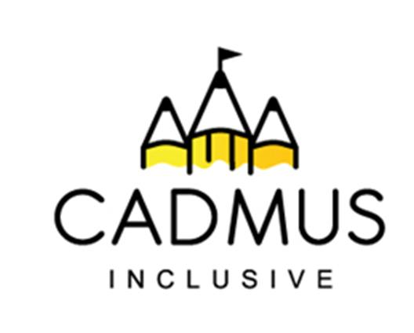

Thinking differently for a brighter tomorrow...

Makaton - Level One
£90 per delegate
Friday 13th March 2026, 9:00 am until 4:00 pm
What do we offer?
Level one Makaton training is the perfect starting point for learning Makaton. Our level one course is delivered by our qualified and experienced Makaton tutor – Rebecca Thompson.
Our training day provides a practical introduction to the Makaton Language Programme. The session includes:
- Learning lots of useful signs and symbols,
- Discussing commonly asked questions,
- Hints and tips for effective signing and symbol use,
- How to start using Makaton in your setting.

Resources:
You will receive a Participant's Manual, which includes the Makaton symbols and signs that you learn during the course.
You will also receive a certificate of attendance.
Participants who have completed level one training may then attend further level two, three and four training days.
The cost of this course includes all course resources, a light lunch and refreshments.

Location: The Inclusive Cadmus Hub, Tantarra Street, Chuckery, Walsall, West Midlands, WS1 2HU
Booking: Please use the course purchase order on the reverse.

This course can also be delivered directly into your setting. Contact Beccie Hawes for information
Makaton – Level One
£90 per delegate
Friday 13th March 2026, 9:00 am until 4:00 pm
Purchase Order Number
School/Setting Name and Address
Telephone Number and Email
Who should we send the invoice to? Please include email details.
Delegate Name(s)
Is there anything we can do to help you access our course - for example dietary or special access needs?
Total Purchase Cost:
Signed (please also print your name):
Role:

Once your booking is received all cancellations will be charged at the full course cost price. We are unable to transfer bookings to alternative courses.
Please return your completed course purchase order to:
Beccie Hawes: bhawes@cadmussupportservices.co.uk Tel: 07983 773614

