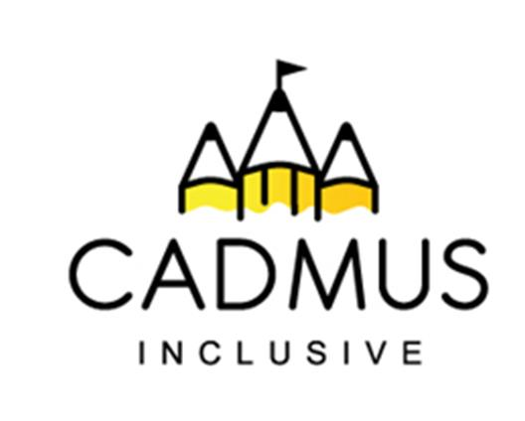

Thinking differently for a brighter tomorrow...

Supporting the Development of Speech Sounds

Thursday 25th June 2026, 1:15pm until 3:30pm

£35

Speech sounds are one of the fundamental building blocks of verbal communication. Furthermore, the ability to recognise and distinguish sounds (phonological awareness) is directly linked to reading, writing, and spelling, as these skills form the basis of phonics.

Clear speech sound development ensures effective communication, social interactions and supports access to learning and literacy.

To help you to give your children the very best start and unlock learning and communication our new face-to-face course explores:

- Input – how to support speech development by providing rich communication input—specifically, auditory, visual, and sometimes tactile cues—to help a child hear the correct sounds and understand how to produce them.
- Clarity – how to support the development, accuracy and ease with which spoken words are understood through supporting precise articulation, steady pacing, appropriate volume, and intonation.
- Production – how to support children in producing accurate speech sounds.
- Fluency – how to support the development of communication fluency.
- Supporting speech production for effective literacy skill development.

Location: The Inclusive Cadmus Hub, Broadmeadow, Aldridge, Walsall WS9 8HZ

Booking: Please use the course purchase order on the reverse.

This course can also be delivered directly into your setting. Contact Beccie Hawes for information.

Supporting the Development of Speech Sounds

Thursday 25th June 2026, 1:15pm until 3:30pm

£35
Purchase Order Number
School/Setting Name and Address
Telephone Number and Email
Who should we send the invoice to? Please include email details.
Delegate Name(s)
Is there anything we can do to help you access our course - for example dietary or special access needs?
Total Purchase Cost:
Signed (please also print your name):
Role:

Once your booking is received all cancellations will be charged at the full course cost price.
Please return your completed course purchase order to:
Beccie Hawes: bhawes@cadmussupportservices.co.uk Tel: 07983 773614

