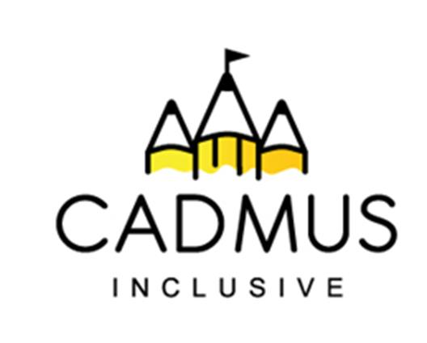

Thinking differently for a brighter tomorrow...

All Kinds of Minds

The term neurodiversity is used to explore the idea that people experience and interact with the world around them in many different ways; there is no one ‘right’ way of thinking, learning, and behaving and differences should not be viewed as deficits. Neurodiversity is the idea that people's brains work in different ways, and that these differences are a natural part of human variation. It's a concept that can help people understand that differences in how people learn, communicate, and experience the world are normal and can be strengths.

To raise awareness and acceptance of this concept, Cadmus Inclusive can offer a range of assemblies and activity-based sessions to create your own unique package to celebrate the theme of ‘All Kinds of Minds’.

Our assemblies, practical class/group sessions and staff training will help both your staff and pupils understand and explore:

- The neuroscience behind how the brain works to create all kinds of minds and the potential impact this has on accessing all aspects of school life.
- The impact that neurodivergence may have on a social level.
- Self-regulation and sensory needs.
- Masking.
- Offering effective support through a relational approach which fosters positive connections and well-being.

You can choose from the following packages:

Packages | Cost
- A 30-minute Key Stage specific assembly,  - 3 classroom 40 minute workshops for up to 30 pupils. | £310 + VAT
- A 30-minute Key Stage specific assembly,  - Six classroom 40 minute workshops for up to 30 pupils. | £600 + VAT
- 4 classroom 40 minute workshops for up to 30 pupils. | £310 + VAT
- 7 classroom 40 minute workshops for up to 30 pupils. | £600 + VAT
- Staff acceptance session (up to 90 minutes):  - Awareness raising,  - Practical and impactful strategies to support neurodivergent learners. | £200 + VAT
- A morning or afternoon session with 2 groups of children to produce “All about me” booklets (Groups 4-10 children). | £310 + VAT
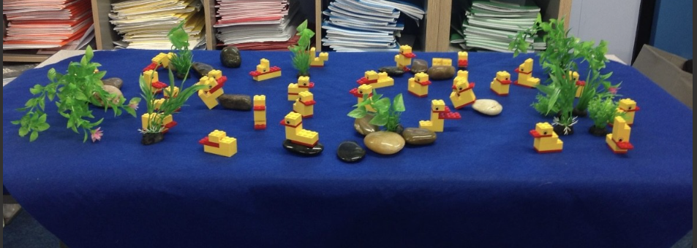

Booking: Please use the course purchase order
included in this document

Contact Emma Yates for information or to build a bespoke packag
eyates@cadmussupportservices.co.uk

Tel: 07415 962784

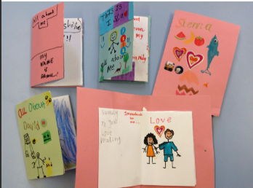

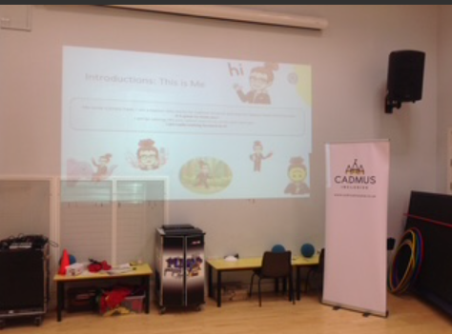

All Kinds of Minds – Purchase Order

Packages | Cost | Purchase
- A 30-minute Key Stage specific assembly,  - 3 classroom 40 minute workshops for up to 30 pupils. | £310 + VAT
- A 30-minute Key Stage specific assembly,  - Six classroom 40 minute workshops for up to 30 pupils. | £600 + VAT
- 4 classroom 40 minute workshops for up to 30 pupils. | £310 + VAT
- 7 classroom 40 minute workshops for up to 30 pupils. | £600 + VAT
- Staff acceptance session (up to 90 minutes):  - Awareness raising,  - Practical and impactful strategies to support neurodivergent learners. | £200 + VAT
- A morning or afternoon session with 2 group of children to produce “All about me” booklets (Groups 4-10 children). | £310 + VAT

Purchase Order Number
School/Setting Name and Address
SENCo/Inclusion Leader contact details (name, telephone and email)
Head Teacher contact details (name, telephone and email)

Who should we invoice (name, telephone and email)?

Total Cost of Purchase + VAT:

Once we receive your purchase order a member of the team will contact you to book your package. Once delivery dates are agreed we require 7 working days’ notice of cancellation or you will be charged at the full price.

Please return your completed purchase orders to Beccie Hawes:

bhawes@cadmusinclusive.co.uk

