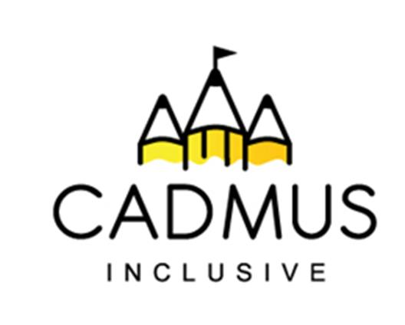

Thinking differently for a brighter tomorrow...

Makaton - Level One
£90 + VAT per delegate
Friday 06th November 2026, 9:00 am until 4:00 pm
What do we offer?
Level one Makaton training is the perfect starting point for learning Makaton. Our level one course is delivered by our qualified and experienced Makaton tutor – Rebecca Thompson.

Our training day provides a practical introduction to the Makaton Language Programme. The session includes:
- Learning lots of useful signs and symbols,
- Discussing commonly asked questions,
- Hints and tips for effective signing and symbol use,
- How to start using Makaton in your setting.

Resources – Digital Learning Kit:
You will receive a Digital Learning Kit to support your Makaton learning during and after the course. This resource is an everlasting digital manual containing the relevant level one relevant signs and videos that you will need for the course and afterwards. To access your Digital Learning Kit a code will be sent to you prior to the course. It is essential that you have the code and a laptop or tablet that you can bring with you on the day of the course to access your resources.

Participants who have completed level one training may then attend further level two, three and four training days.
The cost of this course includes your Digital Learning Kit, a light lunch and refreshments.

Location: The Cadmus Inclusive Hub, Leighswood School, Broad Meadow, Aldridge, WS9 8HZ
Booking: Please use the course purchase order on the reverse
This course can also be delivered directly into your setting. Contact Beccie Hawes for information.

Makaton – Level One
£90 + VAT per delegate
Friday 06th November 2026, 9:00 am until 4:00 pm
Purchase Order Number
School/Setting Name and Address
Telephone Number and Email
Who should we send the invoice to? Please include email details.
Delegate Name and email address (the Digital Learning Kit code will be sent to this address)
Is there anything we can do to help you access our course - for example dietary or special access needs?
I can confirm that the delegate(s) will be able to bring a laptop/device with them on the day and will also bring the code emailed out to them. (Please initial below)
Total Purchase Cost + VAT:
Signed (please also print your name):
Role:

Once your booking is received all cancellations will be charged at the full course cost price. We are unable to transfer bookings to alternative courses.
Please return your completed course purchase order to:
Beccie Hawes: bhawes@cadmussinclusive.co.uk Tel: 07983 773614

