

Cadmus Inclusive

Thinking differently for a brighter tomorrow...

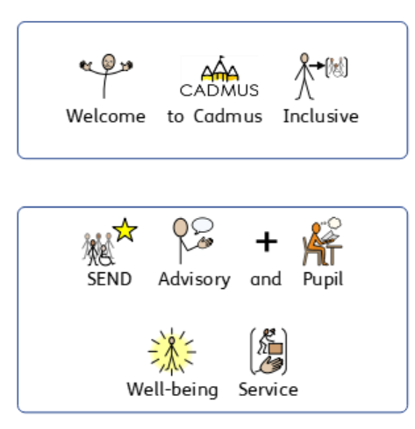

Cadmus Inclusive: SEND Advisory and Pupil Well-Being Service

Inclusion Consultant Team 2026 - 2027

We can offer individually tailored visits to your school. Virtual support is also available. Each visit lasts up to three hours and could feature:
Pupil Support:
- Assessment of pupil needs which can include observation, pupil voice, direct work, standardised assessment, a comprehensive case history, discussions with parents/carers and staff.
- Comprehensive written feedback.
- Support to plan, differentiate and deliver a personalised curriculum.
- Progress reviews.
- Adaptive classroom teaching advice.
- Identification of dyslexia if appropriate.

SENCo Leadership Support to:
- Review and develop policies and procedures including your SEND Information Report.
- Effectively and efficiently implement local and national directives, including the SEND Code of Practice.
- Gather evidence for and produce high quality requests for Education and Health Care needs assessments.
- Evidence pupil progress.
- Plan for innovation.

Curriculum Development:
- Teaching and learning advice – matching adaptive approaches and scaffolding to pupil needs to maximise progress.
- Facilitating greater engagement and independence.

INSET Delivery:
- Bespoke INSET sessions designed in partnership with you delivered in person or virtually.

OFSTED:
- Support with preparation for OFSTED.
- Post OFSTED support to action plan and develop.

SEND Review:
- An in depth review of all aspects of SEND policy, practice and provision with the development of a supportive action plan.

SEND Advisory and Pupil Well-Being Service (Academic Year 2026 – 2027)
Purchase Order Number
School/Setting Name and Address
SENCo/Inclusion Leader contact details (name, telephone and email)
Head Teacher contact details (name, telephone and email)

Who should we invoice (name, telephone and email)?
Purchase Order for a Service Level Agreement - School Visits
Inclusion Consultant Team

Costs for the 2026 – 2027 Academic Year

One-year service level agreement from September 2026 to July 2027: £320 + VAT per session dropping to £290 + VAT per session if 10 or more visits are purchased for the academic year

Number of Visits Required for September 2026 to July 2027 and Cost
Total Cost of Purchase + VAT

Once we receive your purchase order a member of the team will contact you to book an initial visit and share our service level agreement.

Once a school visit/training session has been booked with one of our consultants we require a minimum of 7 working days’ notice to make a cancellation. This is unless there is an OFSTED inspection. In this case we will attempt to find a mutually convenient replacement date. Should a session be unfortunately cancelled by one of our consultants a replacement session will be offered.

Please return your purchase order to Beccie Hawes, Chief Executive Officer
bhawes @cadmussupportservices.co.uk

Meet our Inclusion Consultant Team

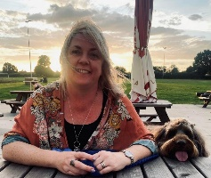  Beccie Hawes, Chief Executive Officer | 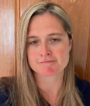  Emma Yates, Deputy Head of Services
Inclusion Consultants
  Ruth Lue-Quee |  | 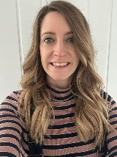  Ali Rolph
  Gemma Ivens |  | 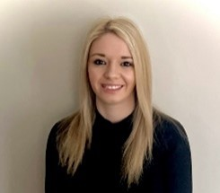  Jordan Jacks
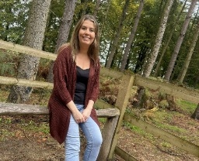

Lou Holmes
SEND Strategic Support Consultant

Simon Muller

