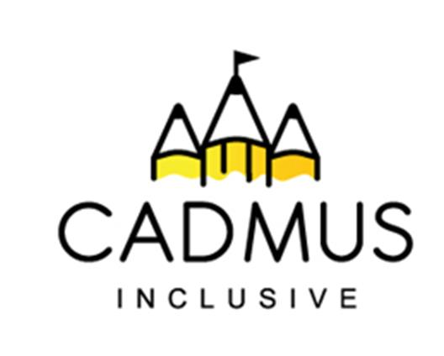

Thinking differently for a brighter tomorrow...

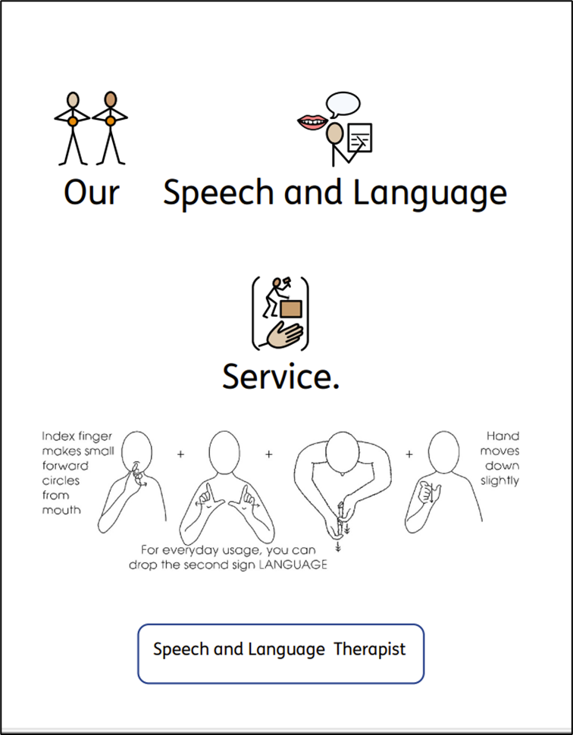

Academic Year 2026 – 2027

The ability to communicate in a meaningful way is as essential life skill. We recognise that everyone meets milestones at different paces. Being able to communicate is an underpinning skill that can influence the whole profile of development. We know from well-founded evidence that early identification of communication needs and effective intervention supports the best life chances and outcomes. That is why we are passionate about ensuring that all children and young people can develop the communication skills required to access learning, share their wishes, feelings, wants and needs to have every chance to make sense of the world around them.

Our neuro-affirming service aims to help pupils, their families and school staff to build those very skills so that our pupils can have a brighter tomorrow! To achieve this aim, our Speech and Language Therapists can offer you:

- Assessment to explore speech sounds, language and social communication with reports and/or targets.
- Individual and/or group therapy sessions.
- Evidence for requests for Education and Health Care Needs Assessments.
- Continued Professional Development.

Costs for the 2026-2027 Academic Year

Offer  All visits are carried out by a qualified and experienced Speech and Language Therapist. | Cost
An Assessment Day  2 pupils will be assessed by a Speech and Language Therapist and reports containing main findings, targets and strategies. | £550 per assessment day
6 Visits Over the Academic Year  This can be used for pupil assessment (two pupils can be assessed in one day), therapy delivery, communication audits and staff training. | £3,240
12 Visits Over the Academic Year  This can be used for pupil assessment (two pupils can be assessed in one day), therapy delivery, communication audits and staff training. | £6,420
24 Visits Over the Academic Year  This can be used for pupil assessment (two pupils can be assessed in one day), therapy delivery, communication audits and staff training. | £12,720
Bespoke packages can be purchased.
Please contact bhawes@cadmussupportservices.co.uk to discuss your requirements.

Speech and Language Therapy 2026 -2027
Service Level Agreement

Offer  All visits are carried out by a qualified and experienced Speech and Language Therapist. | Cost | Number Required
An Assessment Day  2 pupils will be assessed by a Speech and Language Therapist and reports containing main findings, targets and strategies. | £550 per assessment day
6 Visits Over the Academic Year  This can be used for pupil assessment (two pupils can be assessed in one day), therapy delivery, communication audits and staff training. | £3,240
12 Visits Over the Academic Year  This can be used for pupil assessment (two pupils can be assessed in one day), therapy delivery, communication audits and staff training. | £6,420
24 Visits Over the Academic Year  This can be used for pupil assessment (two pupils can be assessed in one day), therapy delivery, communication audits and staff training. | £12,720

Purchase Order Number
School/Setting Name and Address
SENCo/Inclusion Leader contact details (name, telephone and email)
Head Teacher contact details (name, telephone and email)

Who should we invoice (name, telephone and email)?

Total Cost of Purchase:

Once we receive your purchase order a member of the team will contact you to book an initial visit and share our SaLT School Agreement.

Once a school visit/training visit has been booked with one of our team we require a minimum of 7 working days’ notice to make a cancellation. This is unless there is an OFSTED inspection. In this case we will attempt to find a mutually convenient replacement date. Should a visit be unfortunately cancelled by one of our team a replacement visit will be offered.

Please return your purchase order to Beccie Hawes, Chief Executive Officer
bhawes @cadmussupportservices.co.uk

