

Cadmus Inclusive

Thinking differently for a brighter tomorrow...

Our Sports Mentoring Service 2026-2027

Our sports mentoring service is for pupils that need a different kind of therapeutic approach to supporting their social, emotional and mental health. Your pupils may be experiencing difficulties related to:
- Developing positive self-esteem,
- Self-confidence,
- Resilience,
- Developing positive relationships with others,
- Identifying and managing their own emotions,
- Conflict resolution.
These things can become barriers to accessing and enjoying learning in the classroom and wider school life.

Our sports mentoring service focuses upon empowering pupils to develop their long-term mental well-being by acquiring transferable self-help strategies that will last a lifetime through the medium of sport. Through our sports mentoring sessions your pupils will have the opportunity to engage in a personalised programme that will offer them the opportunity to work 1:1 or in a small group to:
- Identify and explore their strengths,
- Engage in fun and focused physical activity in a safe space,
- Develop supportive self-help strategies,
- Have time and space to share their worries, concerns, needs and wants,
- Set and achieve goals for the future,
- Develop skills and strategies that are transferable to school and beyond,
- Work with a positive role model.

All sessions are led by a qualified, experienced and DBS checked sports mentor from our team who uses a person centered and relational approach to support pupils holistically. Schools and educational settings can purchase regular sessions in which a sports mentor will come to their school to work directly to their pupils.

Pupils that have worked with our Sport Mentors have described them as:
- “Fun, trustworthy, easy to talk to, cool, friendly, kind, patient and good listeners.”
Pupils describe the impact of Sports Mentoring as:
- “I have more positivity; I am a happier person and working in a team is good.”
- “It helped with my feelings when I get frustrated or angry. His advice/strategies helped.”
- “It helped me be more chatty and helped develop my sense of fun.”
(With thanks to Manor Primary School for their feedback)

Meet the team

Introducing Callum and Lewis
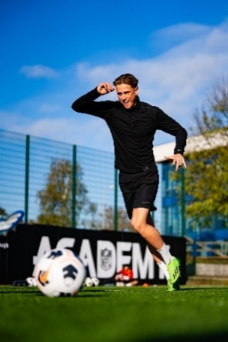
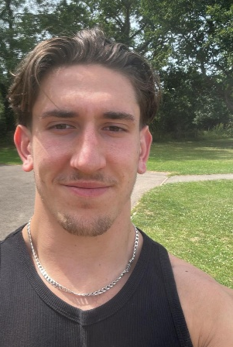

Both Callum and Lewis live and breath all things related to sport. They are passionate about the connection between mind and body and, through their work, help others not only to feel physically and mentally well, but to develop life-lasting skills that they can use to achieve this feeling outside of their sessions. Callum and Lewis actively promote well-being through sport, using it as a vehicle to address and support the many difficulties related to the feelings, emotions and personal challenges many of our children and young people face.

Callum - When not working as a personal trainer and semi-professional footballer, Callum works with children and young people to develop their sports skills. He has considerable experience of delivering PE in schools, has set up and delivered after school sports clubs, organised and delivered sports days and facilitated 1:1 and small group coaching sessions. There is nothing that he hasn’t delivered in the sports space and no sport that he is not willing to explore!

Lewis – Outside of our service, Lewis is a personal trainer and runs mental and physical wellness retreats. He enjoys spending time with his friends and family and enjoys hiking. He is an experienced football coach and enjoys playing football himself. He has a passion for the outdoors and loves to help others to achieve their goals to become the best that they can be.

Through their own life experiences Callum and Lewis understand what it’s like to grow up in today’s challenging and often scary world. This makes them relatable to our children and young people. Callum and Lewis’ relational and pupil-centered approach is always well received.

Active Sports Mentoring Packages 2026 - 2027

Single Visit
A single mentoring session
£225
You receive single visit lasting up to three hours which will consist of:
- 1:1 work for up to three pupils (each pupil session lasting up to 45 minutes).
- Three small 45-minute group sessions (up to 4 pupils).
- This can be a ‘mix and match’ approach of individual pupil and small group sessions within the visit.
A Six Week Mentoring Programme
Six school visits - one per week
£1300
You receive six visits over six weeks lasting up to three hours which will consist of:
- 1:1 work for up to three individual pupils (each pupil session lasting up to 45 minutes) per week.
- Three small 45-minute group sessions (up to 4 pupils) per week.
- This can be part of a ‘mix and match’ of individual and small group sessions within the visit.
A Twelve Week Mentoring Programme
Twelve school visits - one per week
£2300
You receive six visits over six weeks lasting up to three hours which will consist of:
- 1:1 work for up to three individual pupils (each pupil session lasting up to 45 minutes) per week.
- Three small 45-minute group sessions (up to 4 pupils) per week.
- This can be part of a ‘mix and match’ of individual and small group sessions within the visit.
Sports and Social – After School Club
Six weeks - £450
You receive after school sessions over six weeks. Each session lasts for up to 45 minutes and will consist of:
- Six weekly 45 minute sessions for up to 12 pupils.
- Sessions focus on teamwork and building positive relationships.
Full academic year programmes are available upon request. All of our packages are suitable for Primary and Secondary aged pupils.

Purchase Order Number
School/Setting Name and Address
SENCo/Inclusion Leader contact details (name, telephone and email)
Head Teacher contact details (name, telephone and email)

Who should we invoice (name, telephone and email)?

Purchase Order 2025 - 2026
Please Select Your Package
Single Visit
Six Week Programme
Twelve Week Programme
Sports and Social
Whole Year Package (price upon request)

Who should we contact to arrange your sessions?
(Name and contact details)

Once we receive your purchase order a member of the team will contact you to book an initial visit and share our service level agreement contract.
Once a school visit has been booked we require a minimum of 7 working days’ notice to make a cancellation. This is unless there is an OFSTED inspection. In this case we will attempt to find a mutually convenient replacement date. Should a visit be unfortunately cancelled by one of our team a replacement visit will be offered.

Please return your purchase order to Emma Yates, Deputy Head of Services

e.yates@cadmussupportservices.co.uk
Tel:07415 962784

